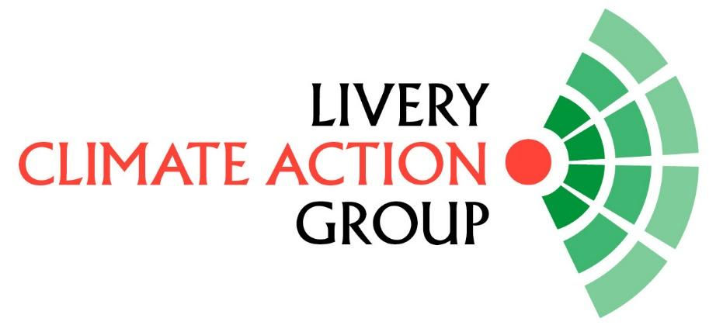
NOMINATION FORM FOR THE EXECUTIVE OF THE LIVERY CLIMATE ACTION GROUP 2025

At the Annual General Meeting to be held on 24th June 2025, any member of the Livery Climate Action Group can nominate one individual to be a member of the Executive for the ensuing year.
There shall be a maximum of 12 members of the Executive and, if more than 12 are nominated, then there shall be a vote at the AGM to determine the 12 members.
Nominating member (company, guild or group):

Name of individual:
Contact details for individual including email, postal address and telephone number:

Signed consent of the individual nominee to be proposed………………………………………………………………………………………………………
Any other details:

Signed for and on behalf of the Nominating member …………………………………………..
Name of signatory and contact email and phone number:

This form is to be submitted as a pdf copy with signatures.
To be returned to info@liverycag.org.uk by no later than 19th June 2025.
Any queries can be directed to info@liverycag.org.uk and copied to alison.gowman@cityoflondon.gov.uk

